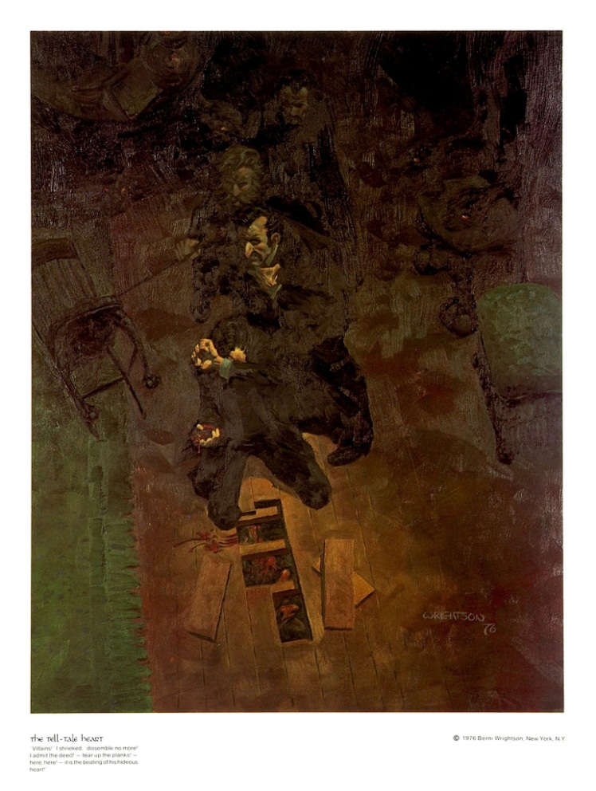
THE TELL-TALE HEART
1843
TRUE! --nervous --very, very dreadfully nervous I had been and am; but why will you say that I am mad? The disease had sharpened my senses --not destroyed --not dulled them. Above all was the sense of hearing acute. I heard all things in the heaven and in the earth. I heard many things in hell. How, then, am I mad? Hearken! and observe how healthily --how calmly I can tell you the whole story.
It is impossible to say how first the idea entered my brain; but once conceived, it haunted me day and night. Object there was none. Passion there was none. I loved the old man. He had never wronged me. He had never given me insult. For his gold I had no desire. I think it was his eye! yes, it was this! He had the eye of a vulture --a pale blue eye, with a film over it. Whenever it fell upon me, my blood ran cold; and so by degrees --very gradually --I made up my mind to take the life of the old man, and thus rid myself of the eye forever.
Now this is the point. You fancy me mad. Madmen know nothing. But you should have seen me. You should have seen how wisely I proceeded --with what caution --with what foresight --with what dissimulation I went to work! I was never kinder to the old man than during the whole week before I killed him. And every night, about midnight, I turned the latch of his door and opened it --oh so gently! And then, when I had made an opening sufficient for my head, I put in a dark lantern, all closed, closed, that no light shone out, and then I thrust in my head. Oh, you would have laughed to see how cunningly I thrust it in! I moved it slowly --very, very slowly, so that I might not disturb the old man's sleep. It took me an hour to place my whole head within the opening so far that I could see him as he lay upon his bed. Ha! would a madman have been so wise as this, And then, when my head was well in the room, I undid the lantern cautiously-oh, so cautiously --cautiously (for the hinges creaked) --I undid it just so much that a single thin ray fell upon the vulture eye. And this I did for seven long nights --every night just at midnight --but I found the eye always closed; and so it was impossible to do the work; for it was not the old man who vexed me, but his Evil Eye. And every morning, when the day broke, I went boldly into the chamber, and spoke courageously to him, calling him by name in a hearty tone, and inquiring how he has passed the night. So you see he would have been a very profound old man, indeed, to suspect that every night, just at twelve, I looked in upon him while he slept.
Upon the eighth night I was more than usually cautious in opening the door. A watch's minute hand moves more quickly than did mine. Never before that night had I felt the extent of my own powers --of my sagacity. I could scarcely contain my feelings of triumph. To think that there I was, opening the door, little by little, and he not even to dream of my secret deeds or thoughts. I fairly chuckled at the idea; and perhaps he heard me; for he moved on the bed suddenly, as if startled. Now you may think that I drew back --but no. His room was as black as pitch with the thick darkness, (for the shutters were close fastened, through fear of robbers,) and so I knew that he could not see the opening of the door, and I kept pushing it on steadily, steadily.
I had my head in, and was about to open the lantern, when my thumb slipped upon the tin fastening, and the old man sprang up in bed, crying out --"Who's there?"
I kept quite still and said nothing. For a whole hour I did not move a muscle, and in the meantime I did not hear him lie down. He was still sitting up in the bed listening; --just as I have done, night after night, hearkening to the death watches in the wall.
Presently I heard a slight groan, and I knew it was the groan of mortal terror. It was not a groan of pain or of grief --oh, no! --it was the low stifled sound that arises from the bottom of the soul when overcharged with awe. I knew the sound well. Many a night, just at midnight, when all the world slept, it has welled up from my own bosom, deepening, with its dreadful echo, the terrors that distracted me. I say I knew it well. I knew what the old man felt, and pitied him, although I chuckled at heart. I knew that he had been lying awake ever since the first slight noise, when he had turned in the bed. His fears had been ever since growing upon him. He had been trying to fancy them causeless, but could not. He had been saying to himself --"It is nothing but the wind in the chimney --it is only a mouse crossing the floor," or "It is merely a cricket which has made a single chirp." Yes, he had been trying to comfort himself with these suppositions: but he had found all in vain. All in vain; because Death, in approaching him had stalked with his black shadow before him, and enveloped the victim. And it was the mournful influence of the unperceived shadow that caused him to feel --although he neither saw nor heard --to feel the presence of my head within the room.
When I had waited a long time, very patiently, without hearing him lie down, I resolved to open a little --a very, very little crevice in the lantern. So I opened it --you cannot imagine how stealthily, stealthily --until, at length a simple dim ray, like the thread of the spider, shot from out the crevice and fell full upon the vulture eye.
It was open --wide, wide open --and I grew furious as I gazed upon it. I saw it with perfect distinctness --all a dull blue, with a hideous veil over it that chilled the very marrow in my bones; but I could see nothing else of the old man's face or person: for I had directed the ray as if by instinct, precisely upon the damned spot.
And have I not told you that what you mistake for madness is but over-acuteness of the sense? --now, I say, there came to my ears a low, dull, quick sound, such as a watch makes when enveloped in cotton. I knew that sound well, too. It was the beating of the old man's heart. It increased my fury, as the beating of a drum stimulates the soldier into courage.
But even yet I refrained and kept still. I scarcely breathed. I held the lantern motionless. I tried how steadily I could maintain the ray upon the eve. Meantime the hellish tattoo of the heart increased. It grew quicker and quicker, and louder and louder every instant. The old man's terror must have been extreme! It grew louder, I say, louder every moment! --do you mark me well I have told you that I am nervous: so I am. And now at the dead hour of the night, amid the dreadful silence of that old house, so strange a noise as this excited me to uncontrollable terror. Yet, for some minutes longer I refrained and stood still. But the beating grew louder, louder! I thought the heart must burst. And now a new anxiety seized me --the sound would be heard by a neighbour! The old man's hour had come! With a loud yell, I threw open the lantern and leaped into the room. He shrieked once --once only. In an instant I dragged him to the floor, and pulled the heavy bed over him. I then smiled gaily, to find the deed so far done. But, for many minutes, the heart beat on with a muffled sound. This, however, did not vex me; it would not be heard through the wall. At length it ceased. The old man was dead. I removed the bed and examined the corpse. Yes, he was stone, stone dead. I placed my hand upon the heart and held it there many minutes. There was no pulsation. He was stone dead. His eve would trouble me no more.
If still you think me mad, you will think so no longer when I describe the wise precautions I took for the concealment of the body. The night waned, and I worked hastily, but in silence. First of all I dismembered the corpse. I cut off the head and the arms and the legs.
I then took up three planks from the flooring of the chamber, and deposited all between the scantlings. I then replaced the boards so cleverly, so cunningly, that no human eye --not even his --could have detected any thing wrong. There was nothing to wash out --no stain of any kind --no blood-spot whatever. I had been too wary for that. A tub had caught all --ha! ha!
When I had made an end of these labors, it was four o'clock --still dark as midnight. As the bell sounded the hour, there came a knocking at the street door. I went down to open it with a light heart, --for what had I now to fear? There entered three men, who introduced themselves, with perfect suavity, as officers of the police. A shriek had been heard by a neighbour during the night; suspicion of foul play had been aroused; information had been lodged at the police office, and they (the officers) had been deputed to search the premises.
I smiled, --for what had I to fear? I bade the gentlemen welcome. The shriek, I said, was my own in a dream. The old man, I mentioned, was absent in the country. I took my visitors all over the house. I bade them search --search well. I led them, at length, to his chamber. I showed them his treasures, secure, undisturbed. In the enthusiasm of my confidence, I brought chairs into the room, and desired them here to rest from their fatigues, while I myself, in the wild audacity of my perfect triumph, placed my own seat upon the very spot beneath which reposed the corpse of the victim.
The officers were satisfied. My manner had convinced them. I was singularly at ease. They sat, and while I answered cheerily, they chatted of familiar things. But, ere long, I felt myself getting pale and wished them gone. My head ached, and I fancied a ringing in my ears: but still they sat and still chatted. The ringing became more distinct: --It continued and became more distinct: I talked more freely to get rid of the feeling: but it continued and gained definiteness --until, at length, I found that the noise was not within my ears.
No doubt I now grew very pale; --but I talked more fluently, and with a heightened voice. Yet the sound increased --and what could I do? It was a low, dull, quick sound --much such a sound as a watch makes when enveloped in cotton. I gasped for breath --and yet the officers heard it not. I talked more quickly --more vehemently; but the noise steadily increased. I arose and argued about trifles, in a high key and with violent gesticulations; but the noise steadily increased. Why would they not be gone? I paced the floor to and fro with heavy strides, as if excited to fury by the observations of the men --but the noise steadily increased. Oh God! what could I do? I foamed --I raved --I swore! I swung the chair upon which I had been sitting, and grated it upon the boards, but the noise arose over all and continually increased. It grew louder --louder --louder! And still the men chatted pleasantly, and smiled. Was it possible they heard not? Almighty God! --no, no! They heard! --they suspected! --they knew! --they were making a mockery of my horror!-this I thought, and this I think. But anything was better than this agony! Anything was more tolerable than this derision! I could bear those hypocritical smiles no longer! I felt that I must scream or die! and now --again! --hark! louder! louder! louder! louder!
"Villains!" I shrieked, "dissemble no more! I admit the deed! --tear up the planks! here, here! --It is the beating of his hideous heart!"

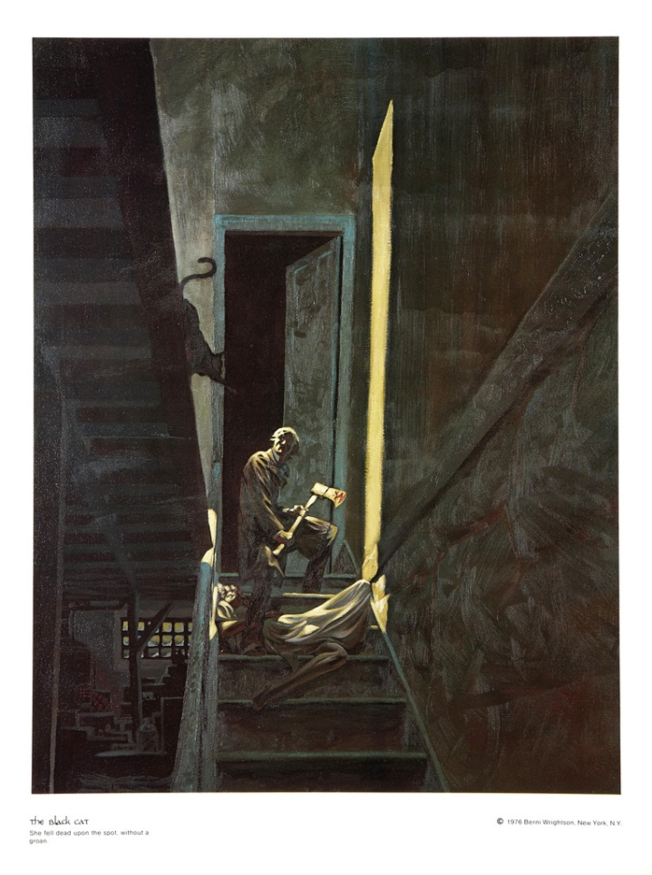

THE BLACK CAT
(1843)
FOR the most wild, yet most homely narrative which I am about to pen, I neither expect nor solicit belief. Mad indeed would I be to expect it, in a case where my very senses reject their own evidence. Yet, mad am I not--and very surely do I not dream. But to-morrow I die, and to-day I would unburden my soul. My immediate purpose is to place before the world, plainly, succinctly, and without comment, a series of mere household events. In their consequences, these events have terrified--have tortured--have destroyed me. Yet I will not attempt to expound them. To me, they have presented little but Horror--to many they will seem less terrible than baroques. Hereafter, perhaps, some intellect may be found which will reduce my phantasm to the commonplace--some intellect more calm, more logical, and far less excitable than my own, which will perceive, in the circumstances I detail with awe, nothing more than an ordinary succession of very natural causes and effects.
From my infancy I was noted for the docility and humanity of my disposition. My tenderness of heart was even so conspicuous as to make me the jest of my companions. I was especially fond of animals, and was indulged by my parents with a great variety of pets. With these I spent most of my time, and never was so happy as when feeding and caressing them. This peculiar of character grew with my growth, and, in my manhood, I derived from it one of my principal sources of pleasure. To those who have cherished an affection for a faithful and sagacious dog, I need hardly be at the trouble of explaining the nature or the intensity of the gratification thus derivable. There is something in the unselfish and self-sacrificing love of a brute, which goes directly to the heart of him who has had frequent occasion to test the paltry friendship and gossamer fidelity of mere Man.
I married early, and was happy to find in my wife a disposition not uncongenial with my own. Observing my partiality for domestic pets, she lost no opportunity of procuring those of the most agreeable kind. We had birds, gold-fish, a fine dog, rabbits, a small monkey, and a cat.
This latter was a remarkably large and beautiful animal, entirely black, and sagacious to an astonishing degree. In speaking of his intelligence, my wife, who at heart was not a little tinctured with superstition, made frequent allusion to the ancient popular notion, which regarded all black cats as witches in disguise. Not that she was ever serious upon this point--and I mention the matter at all for no better reason than that it happens, just now, to be remembered.
Pluto--this was the cat's name--was my favorite pet and playmate. I alone fed him, and he attended me wherever I went about the house. It was even with difficulty that I could prevent him from following me through the streets.
Our friendship lasted, in this manner, for several years, during which my general temperament and character--through the instrumentality of the Fiend Intemperance--had (I blush to confess it) experienced a radical alteration for the worse. I grew, day by day, more moody, more irritable, more regardless of the feelings of others. I suffered myself to use intemperate language to my wife. At length, I even offered her personal violence. My pets, of course, were made to feel the change in my disposition. I not only neglected, but ill-used them. For Pluto, however, I still retained sufficient regard to restrain me from maltreating him, as I made no scruple of maltreating the rabbits, the monkey, or even the dog, when by, accident, or through affection, they came in my way. But my disease grew upon me--for what disease is like Alcohol!--and at length even Pluto, who was now becoming old, and consequently somewhat peevish--even Pluto began to experience the effects of my ill temper.
One night, returning home, much intoxicated, from one of my haunts about town, I fancied that the cat avoided my presence. I seized him; when, in his fright at my violence, he inflicted a slight wound upon my hand with his teeth. The fury of a demon instantly possessed me. I knew myself no longer. My original soul seemed, at once, to take its flight from my body; and a more than fiendish malevolence, gin-nurtured, thrilled every fibre of my frame. I took from my waistcoat-pocket a penknife, opened it, grasped the poor beast by the throat, and deliberately cut one of its eyes from the socket! I blush, I burn, I shudder, while I pen the damnable atrocity.
When reason returned with the morning--when I had slept off the fumes of the night's debauch--I experienced a sentiment half of horror, half of remorse, for the crime of which I had been guilty; but it was, at best, a feeble and equivocal feeling, and the soul remained untouched. I again plunged into excess, and soon drowned in wine all memory of the deed.
In the meantime the cat slowly recovered. The socket of the lost eye presented, it is true, a frightful appearance, but he no longer appeared to suffer any pain. He went about the house as usual, but, as might be expected, fled in extreme terror at my approach. I had so much of my old heart left, as to be at first grieved by this evident dislike on the part of a creature which had once so loved me. But this feeling soon gave place to irritation. And then came, as if to my final and irrevocable overthrow, the spirit of PERVERSENESS. Of this spirit philosophy takes no account. Yet I am not more sure that my soul lives, than I am that perverseness is one of the primitive impulses of the human heart--one of the indivisible primary faculties, or sentiments, which give direction to the character of Man. Who has not, a hundred times, found himself committing a vile or a stupid action, for no other reason than because he knows he should not? Have we not a perpetual inclination, in the teeth of our best judgment, to violate that which is Law, merely because we understand it to be such? This spirit of perverseness, I say, came to my final overthrow. It was this unfathomable longing of the soul to vex itself--to offer violence to its own nature--to do wrong for the wrong's sake only--that urged me to continue and finally to consummate the injury I had inflicted upon the unoffending brute. One morning, in cool blood, I slipped a noose about its neck and hung it to the limb of a tree;--hung it with the tears streaming from my eyes, and with the bitterest remorse at my heart;--hung it because I knew that it had loved me, and because I felt it had given me no reason of offence;--hung it because I knew that in so doing I was committing a sin--a deadly sin that would so jeopardize my immortal soul as to place it--if such a thing were possible--even beyond the reach of the infinite mercy of the Most Merciful and Most Terrible God.
On the night of the day on which this cruel deed was done, I was aroused from sleep by the cry of fire. The curtains of my bed were in flames. The whole house was blazing. It was with great difficulty that my wife, a servant, and myself, made our escape from the conflagration. The destruction was complete. My entire worldly wealth was swallowed up, and I resigned myself thenceforward to despair.
I am above the weakness of seeking to establish a sequence of cause and effect, between the disaster and the atrocity. But I am detailing a chain of facts--and wish not to leave even a possible link imperfect. On the day succeeding the fire, I visited the ruins. The walls, with one exception, had fallen in. This exception was found in a compartment wall, not very thick, which stood about the middle of the house, and against which had rested the head of my bed. The plastering had here, in great measure, resisted the action of the fire --a fact which I attributed to its having been recently spread. About this wall a dense crowd were collected, and many persons seemed to be examining a particular portion of it with every minute and eager attention. The words "strange!" "singular!" and other similar expressions, excited my curiosity. I approached and saw, as if graven in bas relief upon the white surface, the figure of a gigantic cat. The impression was given with an accuracy truly marvellous. There was a rope about the animal's neck.
When I first beheld this apparition--for I could scarcely regard it as less--my wonder and my terror were extreme. But at length reflection came to my aid. The cat, I remembered, had been hung in a garden adjacent to the house. Upon the alarm of fire, this garden had been immediately filled by the crowd--by some one of whom the animal must have been cut from the tree and thrown, through an open window, into my chamber. This had probably been done with the view of arousing me from sleep. The falling of other walls had compressed the victim of my cruelty into the substance of the freshly-spread plaster; the lime of which, had then with the flames, and the ammonia from the carcass, accomplished the portraiture as I saw it.
Although I thus readily accounted to my reason, if not altogether to my conscience, for the startling fact 'just detailed, it did not the less fail to make a deep impression upon my fancy. For months I could not rid myself of the phantasm of the cat; and, during this period, there came back into my spirit a half-sentiment that seemed, but was not, remorse. I went so far as to regret the loss of the animal, and to look about me, among the vile haunts which I now habitually frequented, for another pet of the same species, and of somewhat similar appearance, with which to supply its place.
One night as I sat, half stupefied, in a den of more than infamy, my attention was suddenly drawn to some black object, reposing upon the head of one of the immense hogsheads of gin, or of rum, which constituted the chief furniture of the apartment. I had been looking steadily at the top of this hogshead for some minutes, and what now caused me surprise was the fact that I had not sooner perceived the object thereupon. I approached it, and touched it with my hand. It was a black cat--a very large one--fully as large as Pluto, and closely resembling him in every respect but one. Pluto had not a white hair upon any portion of his body; but this cat had a large, although indefinite splotch of white, covering nearly the whole region of the breast.
Upon my touching him, he immediately arose, purred loudly, rubbed against my hand, and appeared delighted with my notice. This, then, was the very creature of which I was in search. I at once offered to purchase it of the landlord; but this person made no claim to it--knew nothing of it--had never seen it before.
I continued my caresses, and, when I prepared to go home, the animal evinced a disposition to accompany me. I permitted it to do so; occasionally stooping and patting it as I proceeded. When it reached the house it domesticated itself at once, and became immediately a great favorite with my wife.
For my own part, I soon found a dislike to it arising within me. This was just the reverse of what I had anticipated; but I know not how or why it was--its evident fondness for myself rather disgusted and annoyed me. By slow degrees, these feelings of disgust and annoyance rose into the bitterness of hatred. I avoided the creature; a certain sense of shame, and the remembrance of my former deed of cruelty, preventing me from physically abusing it. I did not, for some weeks, strike, or otherwise violently ill use it; but gradually--very gradually--I came to look upon it with unutterable loathing, and to flee silently from its odious presence, as from the breath of a pestilence.
What added, no doubt, to my hatred of the beast, was the discovery, on the morning after I brought it home, that, like Pluto, it also had been deprived of one of its eyes. This circumstance, however, only endeared it to my wife, who, as I have already said, possessed, in a high degree, that humanity of feeling which had once been my distinguishing trait, and the source of many of my simplest and purest pleasures.
With my aversion to this cat, however, its partiality for myself seemed to increase. It followed my footsteps with a pertinacity which it would be difficult to make the reader comprehend. Whenever I sat, it would crouch beneath my chair, or spring upon my knees, covering me with its loathsome caresses. If I arose to walk it would get between my feet and thus nearly throw me down, or, fastening its long and sharp claws in my dress, clamber, in this manner, to my breast. At such times, although I longed to destroy it with a blow, I was yet withheld from so doing, partly it at by a memory of my former crime, but chiefly--let me confess it at once--by absolute dread of the beast.
This dread was not exactly a dread of physical evil--and yet I should be at a loss how otherwise to define it. I am almost ashamed to own--yes, even in this felon's cell, I am almost ashamed to own--that the terror and horror with which the animal inspired me, had been heightened by one of the merest chimeras it would be possible to conceive. My wife had called my attention, more than once, to the character of the mark of white hair, of which I have spoken, and which constituted the sole visible difference between the strange beast and the one I had destroyed. The reader will remember that this mark, although large, had been originally very indefinite; but, by slow degrees--degrees nearly imperceptible, and which for a long time my reason struggled to reject as fanciful--it had, at length, assumed a rigorous distinctness of outline. It was now the representation of an object that I shudder to name--and for this, above all, I loathed, and dreaded, and would have rid myself of the monster had I dared--it was now, I say, the image of a hideous--of a ghastly thing--of the GALLOWS! --oh, mournful and terrible engine of Horror and of Crime --of Agony and of Death!
And now was I indeed wretched beyond the wretchedness of mere Humanity. And a brute beast--whose fellow I had contemptuously destroyed--a brute beast to work out for me--for me a man, fashioned in the image of the High God--so much of insufferable woe! Alas! neither by day nor by night knew I the blessing of rest any more! During the former the creature left me no moment alone; and, in the latter, I started hourly from dreams of unutterable fear, to find the hot breath of the thing upon my face, and its vast weight--an incarnate nightmare that I had no power to shake off--incumbent eternally upon my heart!
Beneath the pressure of torments such as these, the feeble remnant of the good within me succumbed. Evil thoughts became my sole intimates--the darkest and most evil of thoughts. The moodiness of my usual temper increased to hatred of all things and of all mankind; while, from the sudden, frequent, and ungovernable outbursts of a fury to which I now blindly abandoned myself, my uncomplaining wife, alas! was the most usual and the most patient of sufferers.
One day she accompanied me, upon some household errand, into the cellar of the old building which our poverty compelled us to inhabit. The cat followed me down the steep stairs, and, nearly throwing me headlong, exasperated me to madness. Uplifting an axe, and forgetting, in my wrath, the childish dread which had hitherto stayed my hand, I aimed a blow at the animal which, of course, would have proved instantly fatal had it descended as I wished. But this blow was arrested by the hand of my wife. Goaded, by the interference, into a rage more than demoniacal, I withdrew my arm from her grasp and buried the axe in her brain. She fell dead upon the spot, without a groan.
This hideous murder accomplished, I set myself forthwith, and with entire deliberation, to the task of concealing the body. I knew that I could not remove it from the house, either by day or by night, without the risk of being observed by the neighbors. Many projects entered my mind. At one period I thought of cutting the corpse into minute fragments, and destroying them by fire. At another, I resolved to dig a grave for it in the floor of the cellar. Again, I deliberated about casting it in the well in the yard--about packing it in a box, as if merchandize, with the usual arrangements, and so getting a porter to take it from the house. Finally I hit upon what I considered a far better expedient than either of these. I determined to wall it up in the cellar--as the monks of the Middle Ages are recorded to have walled up their victims.
For a purpose such as this the cellar was well adapted. Its walls were loosely constructed, and had lately been plastered throughout with a rough plaster, which the dampness of the atmosphere had prevented from hardening. Moreover, in one of the walls was a projection, caused by a false chimney, or fireplace, that had been filled up, and made to resemble the rest of the cellar. I made no doubt that I could readily displace the at this point, insert the corpse, and wall the whole up as before, so that no eye could detect anything suspicious.
And in this calculation I was not deceived. By means of a crowbar I easily dislodged the bricks, and, having carefully deposited the body against the inner wall, I propped it in that position, while with little trouble, I relaid the whole structure as it originally stood. Having procured mortar, sand, and hair, with every possible precaution, I prepared a plaster which could not be distinguished from the old, and with this I very carefully went over the new brick-work. When I had finished, I felt satisfied that all was right. The wall did not present the slightest appearance of having been disturbed. The rubbish on the floor was picked up with the minutest care. I looked around triumphantly, and said to myself --"Here at least, then, my labor has not been in vain."
My next step was to look for the beast which had been the cause of so much wretchedness; for I had, at length, firmly resolved to put it to death. Had I been able to meet with it, at the moment, there could have been no doubt of its fate; but it appeared that the crafty animal had been alarmed at the violence of my previous anger, and forebore to present itself in my present mood. It is impossible to describe or to imagine the deep, the blissful sense of relief which the absence of the detested creature occasioned in my bosom. It did not make its appearance during the night--and thus for one night at least, since its introduction into the house, I soundly and tranquilly slept; aye, slept even with the burden of murder upon my soul!
The second and the third day passed, and still my tormentor came not. Once again I breathed as a freeman. The monster, in terror, had fled the premises forever! I should behold it no more! My happiness was supreme! The guilt of my dark deed disturbed me but little. Some few inquiries had been made, but these had been readily answered. Even a search had been instituted--but of course nothing was to be discovered. I looked upon my future felicity as secured.
Upon the fourth day of the assassination, a party of the police came, very unexpectedly, into the house, and proceeded again to make rigorous investigation of the premises. Secure, however, in the inscrutability of my place of concealment, I felt no embarrassment whatever. The officers bade me accompany them in their search. They left no nook or corner unexplored. At length, for the third or fourth time, they descended into the cellar. I quivered not in a muscle. My heart beat calmly as that of one who slumbers in innocence. I walked the cellar from end to end. I folded my arms upon my bosom, and roamed easily to and fro. The police were thoroughly satisfied and prepared to depart. The glee at my heart was too strong to be restrained. I burned to say if but one word, by way of triumph, and to render doubly sure their assurance of my guiltlessness.
"Gentlemen," I said at last, as the party ascended the steps, "I delight to have allayed your suspicions. I wish you all health, and a little more courtesy. By the bye, gentlemen, this--this is a very well-constructed house," (In the rabid desire to say something easily, I scarcely knew what I uttered at all),--"I may say an excellently well-constructed house. These walls--are you going, gentlemen?--these walls are solidly put together"; and here, through the mere frenzy of bravado, I rapped heavily with a cane which I held in my hand, upon that very portion of the brick-work behind which stood the corpse of the wife of my bosom.
But may God shield and deliver me from the fangs of the Arch-Fiend! No sooner had the reverberation of my blows sunk into silence than I was answered by a voice from within the tomb! --by a cry, at first muffled and broken, like the sobbing of a child, and then quickly swelling into one long, loud, and continuous scream, utterly anomalous and inhuman--a howl--a wailing shriek, half of horror and half of triumph, such as might have arisen only out of hell, conjointly from the throats of the damned in their agony and of the demons that exult in the damnation.
Of my own thoughts it is folly to speak. Swooning, I staggered to the opposite wall. For one instant the party upon the stairs remained motionless, through extremity of terror and of awe. In the next, a dozen stout arms were tolling at the wall. It fell bodily. The corpse, already greatly decayed and clotted with gore, stood erect before the eyes of the spectators. Upon its head, with red extended mouth and solitary eye of fire, sat the hideous beast whose craft had seduced me into murder, and whose informing voice had consigned me to the hangman. I had walled the monster up within the tomb.

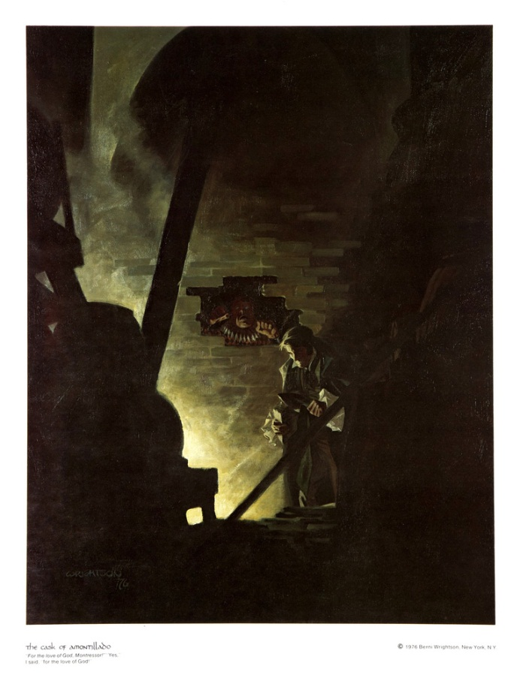

THE CASK OF AMONTILLADO
(1846)
THE thousand injuries of Fortunato I had borne as I best could, but when he ventured upon insult I vowed revenge. You, who so well know the nature of my soul, will not suppose, however, that gave utterance to a threat. At length I would be avenged; this was a point definitely, settled --but the very definitiveness with which it was resolved precluded the idea of risk. I must not only punish but punish with impunity. A wrong is unredressed when retribution overtakes its redresser. It is equally unredressed when the avenger fails to make himself felt as such to him who has done the wrong.
It must be understood that neither by word nor deed had I given Fortunato cause to doubt my good will. I continued, as was my in to smile in his face, and he did not perceive that my to smile now was at the thought of his immolation.
He had a weak point --this Fortunato --although in other regards he was a man to be respected and even feared. He prided himself on his connoisseurship in wine. Few Italians have the true virtuoso spirit. For the most part their enthusiasm is adopted to suit the time and opportunity, to practise imposture upon the British and Austrian millionaires. In painting and gemmary, Fortunato, like his countrymen, was a quack, but in the matter of old wines he was sincere. In this respect I did not differ from him materially; --I was skilful in the Italian vintages myself, and bought largely whenever I could.
It was about dusk, one evening during the supreme madness of the carnival season, that I encountered my friend. He accosted me with excessive warmth, for he had been drinking much. The man wore motley. He had on a tight-fitting parti-striped dress, and his head was surmounted by the conical cap and bells. I was so pleased to see him that I thought I should never have done wringing his hand.
I said to him --"My dear Fortunato, you are luckily met. How remarkably well you are looking to-day. But I have received a pipe of what passes for Amontillado, and I have my doubts."
"How?" said he. "Amontillado, A pipe? Impossible! And in the middle of the carnival!"
"I have my doubts," I replied; "and I was silly enough to pay the full Amontillado price without consulting you in the matter. You were not to be found, and I was fearful of losing a bargain."
"Amontillado!"
"I have my doubts."
"Amontillado!"
"And I must satisfy them."
"Amontillado!"
"As you are engaged, I am on my way to Luchresi. If any one has a critical turn it is he. He will tell me --"
"Luchresi cannot tell Amontillado from Sherry."
"And yet some fools will have it that his taste is a match for your own.
"Come, let us go."
"Whither?"
"To your vaults."
"My friend, no; I will not impose upon your good nature. I perceive you have an engagement. Luchresi--"
"I have no engagement; --come."
"My friend, no. It is not the engagement, but the severe cold with which I perceive you are afflicted. The vaults are insufferably damp. They are encrusted with nitre."
"Let us go, nevertheless. The cold is merely nothing. Amontillado! You have been imposed upon. And as for Luchresi, he cannot distinguish Sherry from Amontillado."
Thus speaking, Fortunato possessed himself of my arm; and putting on a mask of black silk and drawing a roquelaire closely about my person, I suffered him to hurry me to my palazzo.
There were no attendants at home; they had absconded to make merry in honour of the time. I had told them that I should not return until the morning, and had given them explicit orders not to stir from the house. These orders were sufficient, I well knew, to insure their immediate disappearance, one and all, as soon as my back was turned.
I took from their sconces two flambeaux, and giving one to Fortunato, bowed him through several suites of rooms to the archway that led into the vaults. I passed down a long and winding staircase, requesting him to be cautious as he followed. We came at length to the foot of the descent, and stood together upon the damp ground of the catacombs of the Montresors.
The gait of my friend was unsteady, and the bells upon his cap jingled as he strode.
"The pipe," he said.
"It is farther on," said I; "but observe the white web-work which gleams from these cavern walls."
He turned towards me, and looked into my eves with two filmy orbs that distilled the rheum of intoxication.
"Nitre?" he asked, at length.
"Nitre," I replied. "How long have you had that cough?"
"Ugh! ugh! ugh! --ugh! ugh! ugh! --ugh! ugh! ugh! --ugh! ugh! ugh! --ugh! ugh! ugh!"
My poor friend found it impossible to reply for many minutes.
"It is nothing," he said, at last.
"Come," I said, with decision, "we will go back; your health is precious. You are rich, respected, admired, beloved; you are happy, as once I was. You are a man to be missed. For me it is no matter. We will go back; you will be ill, and I cannot be responsible. Besides, there is Luchresi --"
"Enough," he said; "the cough's a mere nothing; it will not kill me. I shall not die of a cough."
"True --true," I replied; "and, indeed, I had no intention of alarming you unnecessarily --but you should use all proper caution. A draught of this Medoc will defend us from the damps.
Here I knocked off the neck of a bottle which I drew from a long row of its fellows that lay upon the mould.
"Drink," I said, presenting him the wine.
He raised it to his lips with a leer. He paused and nodded to me familiarly, while his bells jingled.
"I drink," he said, "to the buried that repose around us."
"And I to your long life."
He again took my arm, and we proceeded.
"These vaults," he said, "are extensive."
"The Montresors," I replied, "were a great and numerous family."
"I forget your arms."
"A huge human foot d'or, in a field azure; the foot crushes a serpent rampant whose fangs are imbedded in the heel."
"And the motto?"
"Nemo me impune lacessit."
"Good!" he said.
The wine sparkled in his eyes and the bells jingled. My own fancy grew warm with the Medoc. We had passed through long walls of piled skeletons, with casks and puncheons intermingling, into the inmost recesses of the catacombs. I paused again, and this time I made bold to seize Fortunato by an arm above the elbow.
"The nitre!" I said; "see, it increases. It hangs like moss upon the vaults. We are below the river's bed. The drops of moisture trickle among the bones. Come, we will go back ere it is too late. Your cough --"
"It is nothing," he said; "let us go on. But first, another draught of the Medoc."
I broke and reached him a flagon of De Grave. He emptied it at a breath. His eyes flashed with a fierce light. He laughed and threw the bottle upwards with a gesticulation I did not understand.
I looked at him in surprise. He repeated the movement --a grotesque one.
"You do not comprehend?" he said.
"Not I," I replied.
"Then you are not of the brotherhood."
"How?"
"You are not of the masons."
"Yes, yes," I said; "yes, yes."
"You? Impossible! A mason?"
"A mason," I replied.
"A sign," he said, "a sign."
"It is this," I answered, producing from beneath the folds of my roquelaire a trowel.
"You jest," he exclaimed, recoiling a few paces. "But let us proceed to the Amontillado."
"Be it so," I said, replacing the tool beneath the cloak and again offering him my arm. He leaned upon it heavily. We continued our route in search of the Amontillado. We passed through a range of low arches, descended, passed on, and descending again, arrived at a deep crypt, in which the foulness of the air caused our flambeaux rather to glow than flame.
At the most remote end of the crypt there appeared another less spacious. Its walls had been lined with human remains, piled to the vault overhead, in the fashion of the great catacombs of Paris. Three sides of this interior crypt were still ornamented in this manner. From the fourth side the bones had been thrown down, and lay promiscuously upon the earth, forming at one point a mound of some size. Within the wall thus exposed by the displacing of the bones, we perceived a still interior crypt or recess, in depth about four feet, in width three, in height six or seven. It seemed to have been constructed for no especial use within itself, but formed merely the interval between two of the colossal supports of the roof of the catacombs, and was backed by one of their circumscribing walls of solid granite.
It was in vain that Fortunato, uplifting his dull torch, endeavoured to pry into the depth of the recess. Its termination the feeble light did not enable us to see.
"Proceed," I said; "herein is the Amontillado. As for Luchresi --"
"He is an ignoramus," interrupted my friend, as he stepped unsteadily forward, while I followed immediately at his heels. In niche, and finding an instant he had reached the extremity of the niche, and finding his progress arrested by the rock, stood stupidly bewildered. A moment more and I had fettered him to the granite. In its surface were two iron staples, distant from each other about two feet, horizontally. From one of these depended a short chain, from the other a padlock. Throwing the links about his waist, it was but the work of a few seconds to secure it. He was too much astounded to resist. Withdrawing the key I stepped back from the recess.
"Pass your hand," I said, "over the wall; you cannot help feeling the nitre. Indeed, it is very damp. Once more let me implore you to return. No? Then I must positively leave you. But I must first render you all the little attentions in my power."
"The Amontillado!" ejaculated my friend, not yet recovered from his astonishment.
"True," I replied; "the Amontillado."
As I said these words I busied myself among the pile of bones of which I have before spoken. Throwing them aside, I soon uncovered a quantity of building stone and mortar. With these materials and with the aid of my trowel, I began vigorously to wall up the entrance of the niche.
I had scarcely laid the first tier of the masonry when I discovered that the intoxication of Fortunato had in a great measure worn off. The earliest indication I had of this was a low moaning cry from the depth of the recess. It was not the cry of a drunken man. There was then a long and obstinate silence. I laid the second tier, and the third, and the fourth; and then I heard the furious vibrations of the chain. The noise lasted for several minutes, during which, that I might hearken to it with the more satisfaction, I ceased my labours and sat down upon the bones. When at last the clanking subsided, I resumed the trowel, and finished without interruption the fifth, the sixth, and the seventh tier. The wall was now nearly upon a level with my breast. I again paused, and holding the flambeaux over the mason-work, threw a few feeble rays upon the figure within.
A succession of loud and shrill screams, bursting suddenly from the throat of the chained form, seemed to thrust me violently back. For a brief moment I hesitated, I trembled. Unsheathing my rapier, I began to grope with it about the recess; but the thought of an instant reassured me. I placed my hand upon the solid fabric of the catacombs, and felt satisfied. I reapproached the wall; I replied to the yells of him who clamoured. I re-echoed, I aided, I surpassed them in volume and in strength. I did this, and the clamourer grew still.
It was now midnight, and my task was drawing to a close. I had completed the eighth, the ninth and the tenth tier. I had finished a portion of the last and the eleventh; there remained but a single stone to be fitted and plastered in. I struggled with its weight; I placed it partially in its destined position. But now there came from out the niche a low laugh that erected the hairs upon my head. It was succeeded by a sad voice, which I had difficulty in recognizing as that of the noble Fortunato. The voice said--
"Ha! ha! ha! --he! he! he! --a very good joke, indeed --an excellent jest. We will have many a rich laugh about it at the palazzo --he! he! he! --over our wine --he! he! he!"
"The Amontillado!" I said.
"He! he! he! --he! he! he! --yes, the Amontillado. But is it not getting late? Will not they be awaiting us at the palazzo, the Lady Fortunato and the rest? Let us be gone."
"Yes," I said, "let us be gone."
"For the love of God, Montresor!"
"Yes," I said, "for the love of God!"
But to these words I hearkened in vain for a reply. I grew impatient. I called aloud --
"Fortunato!"
No answer. I called again --
"Fortunato!"
No answer still. I thrust a torch through the remaining aperture and let it fall within. There came forth in return only a jingling of the bells. My heart grew sick; it was the dampness of the catacombs that made it so. I hastened to make an end of my labour. I forced the last stone into its position; I plastered it up. Against the new masonry I re-erected the old rampart of bones. For the half of a century no mortal has disturbed them. In pace requiescat!

For more stories by Edgar Allen Poe, log onto http://xroads.virginia.edu/~hyper/poe/contents.html

