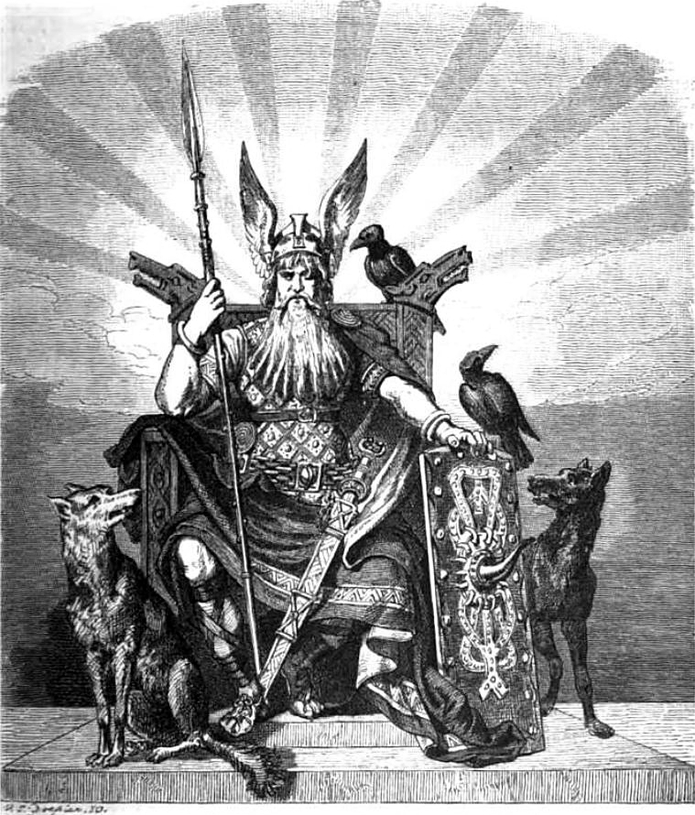
The Norse Creation Myth
abstracted from The Prose Edda of Snorri Sturluson
by D. L. Ashliman
© 1997-2010

Muspell
The first world to exist was Muspell, a place of light and heat whose flames are so hot that those who
are not native to that land cannot endure it.
Surt sits at Muspell's border, guarding the land with a flaming sword. At the end of the world he will
vanquish all the gods and burn the whole world with fire.
Ginnungagap and Niflheim
Beyond Muspell lay the great and yawning void named Ginnungagap, and beyond Ginnungagap lay
the dark, cold realm of Niflheim.
Ice, frost, wind, rain and heavy cold emanated from Niflheim, meeting in Ginnungagap the soft air,
heat, light, and soft air from Muspell.
Ymir
Where heat and cold met appeared thawing drops, and this running fluid grew into a giant frost ogre
named Ymir.
Frost ogres
Ymir slept, falling into a sweat. Under his left arm there grew a man and a woman. And one of his
legs begot a son with the other. This was the beginning of the frost ogres.
Audhumla
Thawing frost then became a cow called Audhumla. Four rivers of milk ran from her teats, and she
fed Ymir.
Buri, Bor, and Bestla
The cow licked salty ice blocks. After one day of licking, she freed a man's hair from the ice. After
two days, his head appeared. On the third day the whole man was there. His name was Buri, and he
was tall, strong, and handsome.
Buri begot a son named Bor, and Bor married Bestla, the daughter of a giant.
Odin, Vili, and Vé
Bor and Bestla had three sons: Odin was the first, Vili the second, and Vé the third.
It is believed that Odin, in association with his brothers, is the ruler of heaven and earth. He is the
greatest and most famous of all men.
The death of Ymir
Odin, Vili, and Vé killed the giant Ymir.
When Ymir fell, there issued from his wounds such a flood of blood, that all the frost ogres were
drowned, except for the giant Bergelmir who escaped with his wife by climbing onto a lur [a
hollowed-out tree trunk that could serve either as a boat or a coffin]. From them spring the families of
frost ogres.
Earth, trees, and mountains
The sons of Bor then carried Ymir to the middle of Ginnungagap and made the world from him. From
his blood they made the sea and the lakes; from his flesh the earth; from his hair the trees; and from
his bones the mountains. They made rocks and pebbles from his teeth and jaws and those bones that
were broken.
Dwarfs
Maggots appeared in Ymir's flesh and came to life. By the decree of the gods they acquired human
understanding and the appearance of men, although they lived in the earth and in rocks.
Sky, clouds, and stars
From Ymir's skull the sons of Bor made the sky and set it over the earth with its four sides. Under
each corner they put a dwarf, whose names are East, West, North, and South.
The sons of Bor flung Ymir's brains into the air, and they became the clouds.
Then they took the sparks and burning embers that were flying about after they had been blown out of
Muspell, and placed them in the midst of Ginnungagap to give light to heaven above and earth
beneath. To the stars they gave appointed places and paths.
The earth was surrounded by a deep sea. The sons of Bor gave lands near the sea to the families of
giants for their settlements.
Midgard
To protect themselves from the hostile giants, the sons of Bor built for themselves an inland
stonghold, using Ymir's eyebrows. This stonghold they named Midgard.
Ask and Embla
While walking along the sea shore the sons of Bor found two trees, and from them they created a man
and a woman.
Odin gave the man and the woman spirit and life. Vili gave them understanding and the power of
movement. Vé gave them clothing and names. The man was named Ask [Ash] and the woman Embla
[Elm]. From Ask and Embla have sprung the races of men who lived in Midgard.
Asgard
In the middle of the world the sons of Bor built for themselves a stronghold named Asgard, called
Troy by later generations. The gods and their kindred lived in Asgard, and many memorable events
have happened there.
In Asgard was a great hall named Hlidskjálf. Odin sat there on a high seat. From there he could look
out over the whole world and see what everyone was doing. He understood everything that he saw.
Odin, Frigg, and the Æsir
Odin married Frigg, the daughter of Fjörgvin. From this family has come all the kindred that inhabited
ancient Asgard and those kingdoms that belonged to it. Members of this family are called the Æsir,
and they are all divinities. This must be the reason why Odin is called All-Father. He is the father of
all the gods and men and of everything that he and his power created.
Thor
The earth was Odin's daughter and his wife as well. By her he had his first son, Thor. Might and
strength were Thor's characteristics. By these he dominates every living creature.
Bifröst
As all informed people know, the gods built a bridge from earth to heaven called Bifröst. Some call it
the rainbow. It has three colors and is very strong, made with more skill and cunning than other
structures. But strong as it is, it will break when the sons of Muspell ride out over it. The gods are not
to blame that this structure will then break. Bifröst is a good bridge, but there is nothing in this world
that can be relied on when the sons of Muspell are on the warpath.
Yggdrasil
The chief sanctuary of the gods is by the ash tree Yggdrasil. There they hold their daily court.
Yggdrasil is the best and greatest of all trees. Its branches spread out over the whole world and reach
up over heaven.
From The Prose Edda: Snorri Sturluson, The Prose Edda, translated from the
Icelandic by Arthur Gilchrist Brodeur (New York: American-Scandinavian Foundation, 1916).
Return to D. L. Ashliman's folktexts, a library of folktales, folklore, fairy tales, and
mythology.
Revised February 17, 2010.

The Norse Creation Myth http://www.pitt.edu/~dash/creation.html

